Regression Models (Linear Regression and Support Vector Machine) for Real-World Health Data prediction

Introduction

Problem Statement
The purpose of this assessment is to apply core regression techniques to real-world health data and develop Linear Regression (LR) and Support Vector Machine (SVM) regression models that can accurately predict “life expectancy” (in years) based on various health, economic and demographic factors.

Dataset Description
The data used in the analysis was originally collected by World Health Organization (WHO). This data was cleaned to create the dataset consisting of 2928 rows and 20 columns/features including the target feature “Life Expectancy”.
Below is a screenshot showing the various features and their associated data types in this dataset.
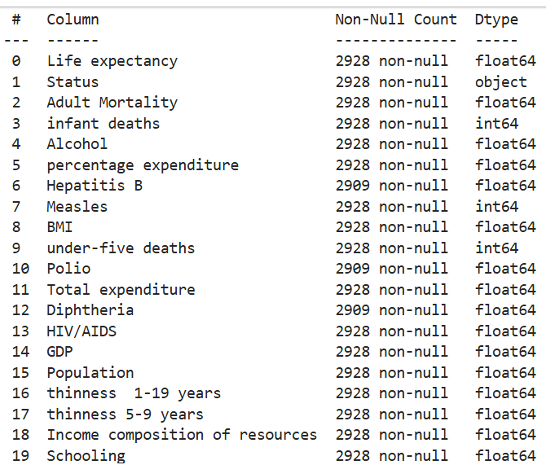
Based on the datatype the features in this dataset can be classified as:
- Categorical - “Status” (Developed/Developing)
- Integer - “infant death”, Measles” and “under-five deaths”
- Float – All remaining features

2. Data preprocessing

2.1. Handling Missing values
The dataset contains 2928 rows and 20 columns. Initial analysis revealed that three features contain missing values:
- Hepatitis B
- Polio
- Diphtheria
Each of these columns/features has 19 missing values each, which accounts for 1.9% of the dataset. The corresponding rows were dropped using dropna() function reducing the dataset to 2909 rows.
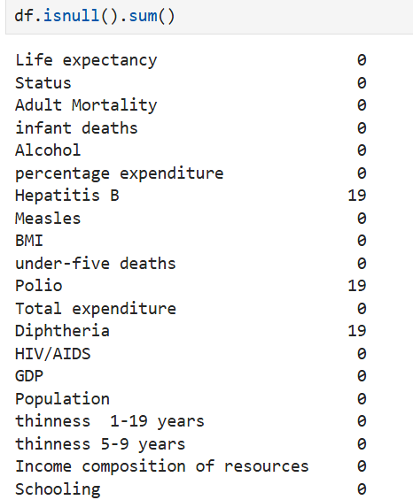

2.2. Handling categorical (ordinal) data
There was only one categorical variable (ordinal variable) “Status” which had two values Developed or Developing. These were converted to numerical values using. replace() function
- Developing – 0
- Developed -1
This helps the variable compatible with machine learning algorithms.

2.3. Checking for duplicates
Duplicate entries can introduce bias into the model training. A check for duplicate entries returned False, confirming no duplicate entries present in the dataset.

2.4. Correlation Analysis
(Géron, A. l. (2019)
A correlation matrix is generated to identify the features most strongly associated with life expectancy. This helps in understanding feature importance and selecting appropriate predictors for regression models.
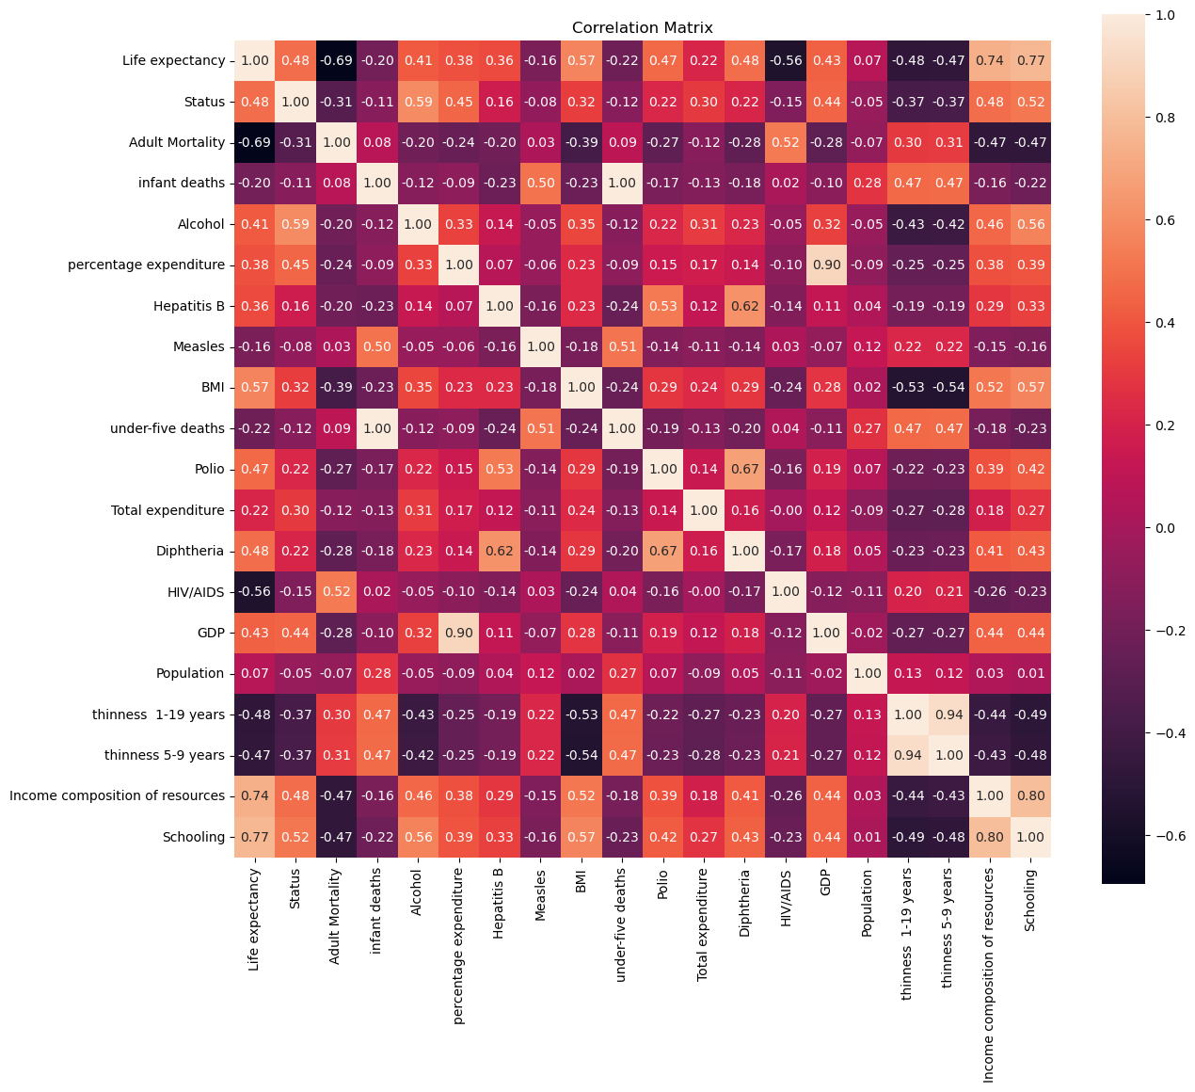

Strong positive correlation
Below are the features that exhibited the strongest positive correlation with life expectancy
Feature | Correlation with life expectancy
Schooling | 0.770689
Income composition of resources | 0.736936
BMI | 0.568102
Status | 0.482606
Diphtheria | 0.479495
Polio | 0.465556
GDP | 0.430741
Alcohol | 0.412648

These results suggest that higher levels of these features are associated with longer life expectancy.

Weak positive correlation
The following features had weak positive correlation between 0 and 0.4. This indicates that they contribute less to the model performance.
Feature | Correlation with life expectancy
percentage expenditure | 0.381974
Hepatitis B | 0.360858
Total expenditure | 0.218134
Population | 0.072770

Negative correlation
Conversely several features were negatively correlated with life expectancy, indicating that higher rates of these are associated with lower life expectancy.
Feature | Correlation with life expectancy
Adult Mortality | -0.694567
HIV/AIDS | -0.557827
thinness 1-19 years | -0.477838
thinness 5-9 years | -0.472177
under-five death | -0.223800
infant deaths | -0.197879
Measles | -0.159975

2.5. Multicollinearity
Multicollinearity was detected using the correlation matrix, where some features are highly correlated with each other.
- “thinness 1-19 years” and “thinness 5-9 years”
- “under-five death” and “infant deaths”
High multicollinearity can distort coefficient estimates in linear regression leading to overfitting. To mitigate this the redundant features “thinness 5-9 years” (a subset of thinness 1-19 years) and “infant deaths” (a subset of under-five death) were removed from the dataset.

2.6. Feature selection and Dimensionality Reduction
Based on correlation analysis few of the columns were removed to simplify the model and reduce noise.
The following criteria were applied:

Removal of weakly correlated features
Features with very low correlation to life expectancy were considered to have limited predictive power and were removed.

Feature | Correlation with life expectancy | Reason for removal
Population | 0.072770 | Very weak positive correlation
Measles | -0.159975 | Really weak negative correlation

Removal of redundant features
To avoid redundancy and multicollinearity, features that overlap in meaning and or represent subsets of other features were also removed
Feature | Related Feature | Reason for removal
Infant deaths | Under-five deaths | Infant deaths are a subset od under-five mortality
Thinness 5-9 years | Thinness 1-19 years | Thinness 5-9 years is a subset of Thinness 1-19 years
After all these data preprocessing steps the final dataset consists of 2909 rows and 16 columns
2.7. Train Test Split
To evaluate model performance and ensure that results generalise to unseen data, the dataset was split into training and testing sets.
- Split ratio: The data was split using 90:10 ratio, where 90% of the records were allocated to the training set and 10% to the test set.
- Random state: A fixed random_state value was used to ensure reproducibility of the split.
This separation ensures that all preprocessing steps that could cause data leakage (such as normalization, log transformation, and skewness calculation) are performed only on the training data. The transformations learned from the training set can then be applied to the test set, preserving its role as truly unseen data for unbiased performance evaluation.

2.8. Summary of Feature Statistics
A quick analysis of feature statistics of training data using describe() function shows that most features have relatively moderate ranges. However, the below features show extreme maximum values, compared to their quartiles:
- Adult mortality
- Percentage expenditure
- Under-five deaths
- HIV/AIDS
- GDP
- Thinness 1-19 years
These large gaps between the median (50%) and maximum values suggest the presence of outliers and potential skewness in these features.

2.9. Log transform of skewed features
Highly skewed features can bias model training and reduce predictive performance. To avoid data leakage skewness was calculated only for training dataset. Log transformation was applied to below features with high skewness
- Adult mortality
- Percentage expenditure
- Under-five deaths
- HIV/AIDS
- GDP
- Thinness 1-19 years
A log transformation using log1p was applied to these features in both training and testing sets to reduce skewness, stabilize variance and enhance robustness of the models.
For Support Vector Regression (SVR), although normally distributed features are not required, the algorithm is sensitive to feature scaling and extreme values. Skewed features can disproportionately influence the decision boundary, so log transformation helps balance feature distributions and improve model stability.
In linear regression, applying a log transformation helps linearise relationships and make residuals more symmetric.
Applying log transformation to these skewed features helped to stabilize variance and improve model robustness, as seen in the improved R² scores during training and testing.

2.10. Normalization of training and testing data
Min-Max normalization was applied after spitting the data into training and test datasets, to prevent data leakage. The scalar was fit only on the training data and then applied to transform both training and testing datasets. This ensured that all feature scales were consistent across datasets while preserving the integrity of the test data.

Model Selection

Regression Models

Linear Regression
Linear regression is a fundamental supervised learning algorithm based on the statistical principle of minimizing the sum of the squared residuals. It models the relationship between one or more independent variables (features) and a continuous dependent variable (target). It assumes a linear association between features and target. The model estimates coefficients for each feature to minimize the sum of squared differences between predicted and the actual target values, typically using the least squares method.

Key parameters:
- Coefficients (weights) – Quantify the effect of each feature
- Intercept- Baseline prediction when all features are zero

Support Vector Regression
Support vector regression (SVR) is an extension of the support vector machine algorithm for regression tasks, derived from the SVM principle of maximizing the margin around a decision function. Unlike linear regression, SVR can model both linear and non-linear relationships using kernel functions (e.g. radial basis function (RBF), polynomial). SVR tries to fit the best function within a margin of tolerance (Epsilon), ignoring errors smaller than this margin, which makes it robust to outliers.

Key parameters:
- C (penalty parameter) - Balances model complexity and prediction accuracy
- Epsilon (€) - Defines the width of the margin within which errors are ignored
- Kernel type and parameters – Determine how input data is transformed for complex relationships (e.g. RBF kernel width gamma r)

Comparison of Linear regression and SVR:
Criteria | Linear Regression (LR) | Support Vector Regression (SVR)
Relationship assumption | Assumes a strictly linear relationship | Can model both linear and non-linear patterns.
Error tolerance | Minimizes all errors | Ignores small deviations within the epsilon margin
Robustness | Sensitive to outliers | More robust to outliers due to its margin-based approach.
Parameters | Coefficients and intercept | C, epsilon, and kernel parameters.

LR and SVR Model execution results with default parameters
To compare the effect of log-transformation, linear regression (LR) and support vector regression (SVR) models were trained with default parameters on both normalised data and log-transformed then normalised data. Model performance was evaluated using the coefficient of determination (R²) on both training and testing datasets.
Model | With normalization |  | With log transformation and normalization |  | Interpretation
Model | Training R² | Testing R² | Training R² | Testing R² | Interpretation
Linear Regression | 0.832 | 0.829 | 0.858 | 0.862 | Model explains 83 - 86% of the variance. Good fit and generalization
Support Vector Regression | 0.873 | 0.864 | 0.892 | 0.885 | Model explains 86 - 88% of the variance. Slightly better fit and generalization than LR

Analysis:
- SVR outperformed LR on both training and testing datasets, demonstrating its ability to capture more complex patterns in the data
- SVR’s higher performance is likely due to its non-linear radial basis function (RBF) kernel which can model more intricate relationships compared to the strictly linear approach of LR
- Across both the models, the log-transformed data achieved higher scores than data without transformation indicating improved model performance and stability.
- The difference in training and testing R² is small suggesting good generalization with the default parameter settings.
- In the case of linear regression with log transformation and normalization, the test R² is slightly higher than the train R² because of a combination of randomness, data distribution and the fact that the linear regression is a low variance model

Five-Fold cross Validation
To further assess the performance of the models, a five-fold cross validation is applied for the log-transformed normalised data. The training dataset was randomly shuffled and split into five equal subsets. In each iteration four folds were used for training and one-fold for validation ensuring that each fold served as the validation set once. The results were averaged to obtain a more reliable performance estimate.
Results:
Model | Individual R2 scores | Average R2 score
Linear Regression | [0.86273512, 0.88229555, 0.82541766, 0.8566875, 0.84948525] | 0.855
Support Vector machine | [0.89301911, 0.88928396, 0.8606831, 0.88108239, 0.87525614] | 0.879
Interpretation:
- SVR achieved a higher R2 score than LR confirming its stronger predictive performance observed in the earlier default model evaluation.
- The small difference between folds in the cross-validation results suggests that both models generalize well into unseen data.

Hyper parameter tuning
Hyperparameter tuning was performed to optimize model performance for both Linear Regression and Support Vector Regression (SVR) models. This was done using GridSearchCV from scikit-learn, which systematically evaluates combinations of hyperparameters through cross-validation and selects the combination that maximizes model performance based on the R² score.

Linear Regression (LR)
For Linear Regression, the following hyperparameters were tuned:
Hyperparameter | Description | Values Tested
fit_intercept | Whether to calculate the intercept of the model or set it to zero. Default is True | True, False
Positive | Whether to constraint the coefficients to be strictly positive. Default is False | True, False

Grid search result:
- Best parameters: fit_intercept = True, positive = False
- Best cross validation R² score: 0.855
- Test R² ⁽Coefficient of Determination): 0.862
- Test RMSE (Root Mean Square Error): 3.43
Table below compares the actual Vs predicted values for the first five test data
Actual Label Value | Predicted Label using LR
76.3 | 78.578850
74.1 | 73.276829
72.8 | 76.685102
74.7 | 73.940348
61.0 | 68.136006
This result confirms that allowing the model to calculate the intercept and not enforcing positive coefficients produced the best performance.

Support Vector Regression (SVR)
For SVR, hyperparameter tuning was more extensive, with separate grids for different kernels. Below hyper parameters were used:
Kernel | Parameters Tuned
linear | C: [1, 10], gamma: [‘auto’, ‘scale’]
rbf | C: [100, 150, 200, 220, 250], gamma: [‘scale’]
poly | C: [6], Degree: [4], Coef0: [3], Gamma: [‘scale’]

Parameter Descriptions:
- C: Regularization parameter controlling the trade-off between bias and variance
- Gamma: Kernel coefficients
- Degree: Degree of the polynomial kernel
- Coef0: Independent term in the polynomial kernel

Grid search result:
- Best parameters: {'C': 200, 'gamma': 'scale', 'kernel': rbf}
- Best cross validation R²: 0.932
- Test R²(Coefficient of Determination): 0.941
- Test RMSE (Root Mean Square Error): 2.24
Notes:
- The large value of C forces the model to fit the training data more closely by penalizing errors more severely.
- The test R² is slightly larger than the train R², which can occur due to random variation and model generalisation.
Table below compares the actual Vs predicted values for the first five test samples:
Actual Label Value | Predicted Label using SVR
76.3 | 76.496069
74.1 | 76.112538
72.8 | 72.956413
74.7 | 74.225528
61.0 | 63.140351
The radial basis function kernel significantly outperformed linear and polynomial SVR kernels, capturing complex nonlinear patterns in the data.

Summary of LR and SVR Model Performance
This section summarizes and compares the predictive performance of Linear Regression (LR) and Support Vector Regression (SVR) models on the World Health Organization health dataset.
Both models were optimized using hyperparameter tuning with cross-validation. The evaluation metrics used were the coefficient of determination (R²) and root mean squared error (RMSE) on the test dataset.
- R² score indicates the proportion of variance explained by the model
- RMSE gives an indication of how far off the predictions are from the actual values.
Model | Best Hyperparameters | Best CV R2 | Test R2 | RMSE (Root Mean Squared Error)
LR | fit_intercept = True, positive = False | 0.855 | 0.862 | 3.43
SVR | 'C': 200, 'gamma': 'scale', 'kernel': rbf | 0.932 | 0.941 | 2.24
Below table compares the actual test labels along with the prediction from LR and SVR models.
Actual Label Value | Predicted Label using LR | Predicted Label using SVR
76.3 | 78.578850 | 76.496069
74.1 | 73.276829 | 76.112538
72.8 | 76.685102 | 72.956413
74.7 | 73.940348 | 74.225528
61.0 | 68.136006 | 63.140351
The SVR model with the radial basis function kernel outperformed Linear Regression by capturing complex nonlinear relationships in the data. This is reflected in its higher R² scores and notably lower RMSE, indicating more accurate predictions on average. These results suggest that SVR is a more robust and effective model for predicting life expectancy based on the given health and demographic features.

References
- scikit-learn https://scikit-learn.org/stable/supervised_learning.html
- Géron, A., & Safari, an O’Reilly Media Company. (2019). Hands-on Machine Learning with Scikit-Learn, Keras, and TensorFlow : concepts, tools, and techniques to build intelligent systems (Second edition..). O’Reilly.
- Sampaio, C. (n.d.). Implementing SVM and kernel SVM with Python’s Scikit-Learn. StackAbuse. https://stackabuse.com/implementing-svm-and-kernel-svm-with-pythons-scikit-learn/
- Berwick, R. (n.d.). An idiot’s guide to support vector machines (SVMs) [PowerPoint slides]. Massachusetts Institute of Technology. https://web.mit.edu/6.034/wwwbob/svm-notes-long-08.pdf

